**A Report**

**on**

**Grocetaria**

Submitted for partial fulfillment of award of

**BACHELOR OF TECHNOLOGY**

degree

In

Computer Science

By

Abhishek Singh (2000320120010)

Abhay Verma (2000320120004)

Anurag Pandey (2000320120042)

Supervisor Name

DHANESHWAR KUMAR



**ABES ENGINEERING COLLEGE, GHAZIABAD,**

## Dr. A P J ABDUL KALAM TECHNICAL UNIVERSITY LUCKNOW

**Dec 2022**

Certificate

This is certified that **………………………………………………….........** has carried out the project work presented in this report entitled **“………………………………………………………………………………”** for the partial fulfillment of **Bachelor of Technology** from, ABEC Engineering college under my supervision. The report embodies result of original work and studies carried out by Student himself/herself and the contents of the report do not form the basis for the award of any other degree to the candidate or to anybody else.

Signature:

Designation:

Address:

Date:

Acknowledgement

We take this opportunity to thank our teachers and friends who helped us throughout the project. First and foremost, I would like to thank my guide for his valuable advice and time during development of project. We would also like to thank **Dr. Pankaj Kumar Sharma (HOD, Computer Science, Department** ) for his constant support during the development of the project.

Name: Abhishek Singh

Roll No. 2000320120010

Signature: Abhishek

Name: Abhay Verma

Roll No: 2000320120004

Signature: Abhay

Name: Anurag Pandey

Roll No. 2000320120042

Signature: Anurag

# Declaration

### I hereby declare that this submission is my own work and that, to the best of my knowledge and belief, it contains no material previously published or written by another person nor material which to a substantial extent has been accepted for the award of any other degree or diploma of the university or other institute of higher learning, except where due acknowledgment has been made in the text.

Name: Abhishek Singh

Roll No. 2000320120010

Signature: Abhishek

Name: Abhay Verma

Roll No: 2000320120004

Signature: Abhay

Name: Anurag Pandey

Roll No. 2000320120042

Signature: Anurag

# Abstract

* Vending and hawking has been an integral part of Indian trade and shopping since ancient times. Without vendors, it is quite challenging and impossible to experience the dynamicity of cities.
* Most of the modern vendors and hawkers are working in an unorganized manner. They usually haul their stalls at specific places and sell over there or have random visiting routes to sell their products door to door.
* Vendors have huge impact on the growth of economy of a country if they are organized at a platform and given suitable tools and techniques to improve their traditional method of selling.
* In this project we are integrating all the unorganized vendors at a single platform where they can sell their products online and can also get customer leads online .On this platform after getting customer lead the vendor can directly reach the door of customer to sell his product .

**TABLE OF CONTENT**

#### CHAPTERNO. PAGE NO.

1. **INTRODUCTION**
2. **LITERATURE REVIEW**
3. **PROPOSED SYSTEM/METHODOLOGY**
4. **IMPLEMTATION/CORE MODIULES**
5. **RESULTS/OUTPUT & TESTING**
6. **CONCLUSION AND RECOMMENDATIONS**

**REFERENCES (IEEE FORMAT only)**

**APPENDICES(review paper prepared for publication)**

INTRODUCTION

* To design a simple and convenient platform that can integrate the distributed and unorganized sector of street vendors.
* To provide the customers a platform from where they can buy products from local vendors by themselves after checking the quality of the products.
* To provide customers a platform from where they can buy products from their homes at competitive prices as compared to online platforms.

PROPOSED METHODOLOGY

* Use of HTML CSS and JAVASCRIPT to design the user interactive landing page.
* Using Google maps API to mark down the locality, path and time during which the area will be visited by the respective vendor.
* Creating a database using firebase for the vendor’s details, customer details, customer buy and search history.
* Integrating online payment system using Razorpay payment gateway.
* Bringing local vendors to website and creating their catalogue.

IMPLEMTATION / CORE MODULES

1.1 MODULE FOR VENDOR LOGIN

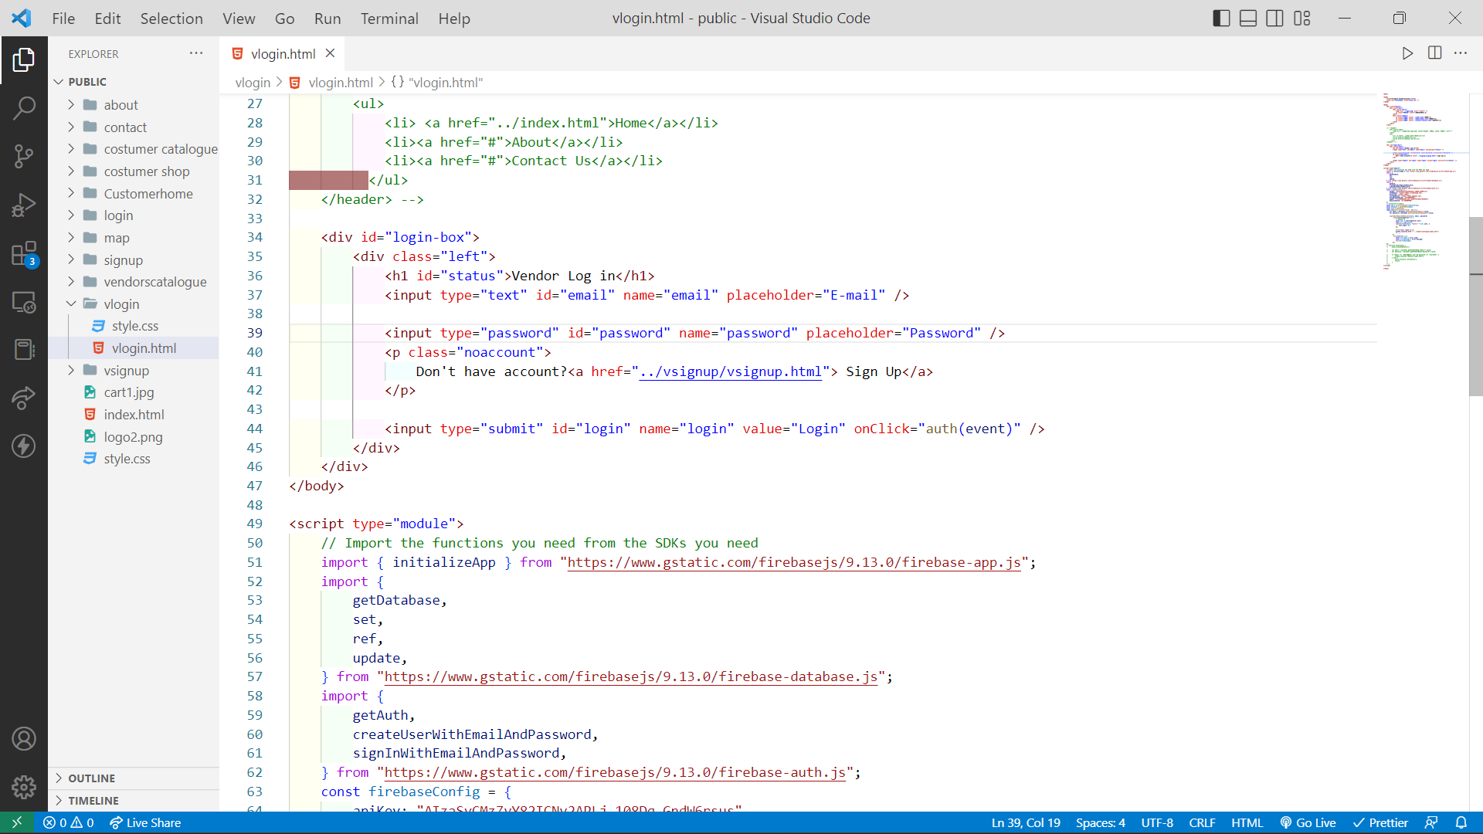

1.2 MODULE FOR VENDOR SIGNUP

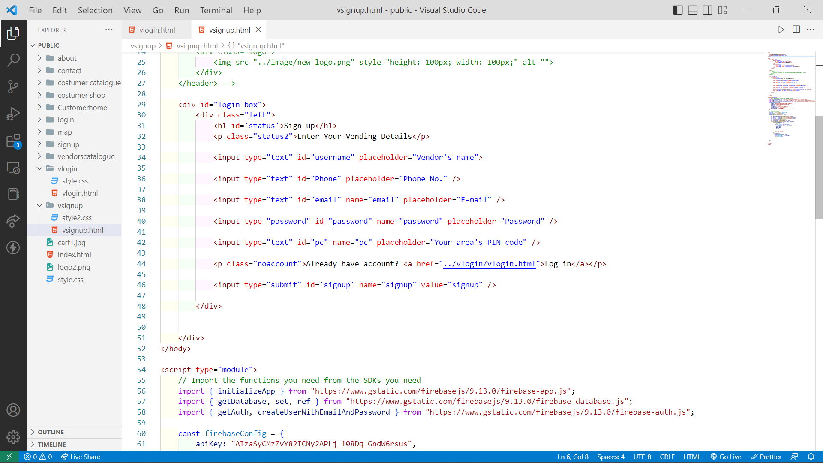

2.1 MODULES FOR CUSTMER LOGIN

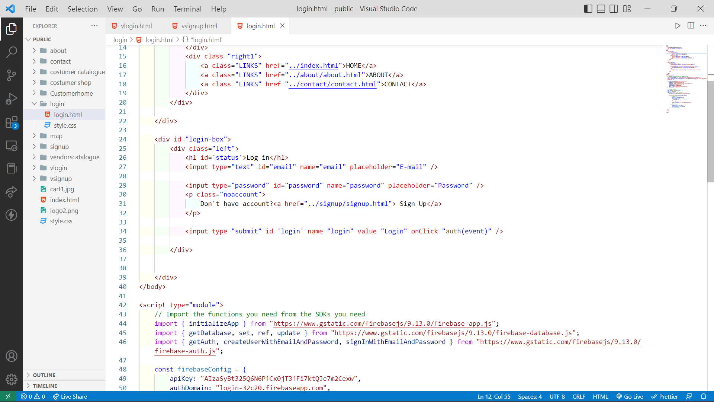

2.2 MODULES FOR CUSTMER SIGNUP

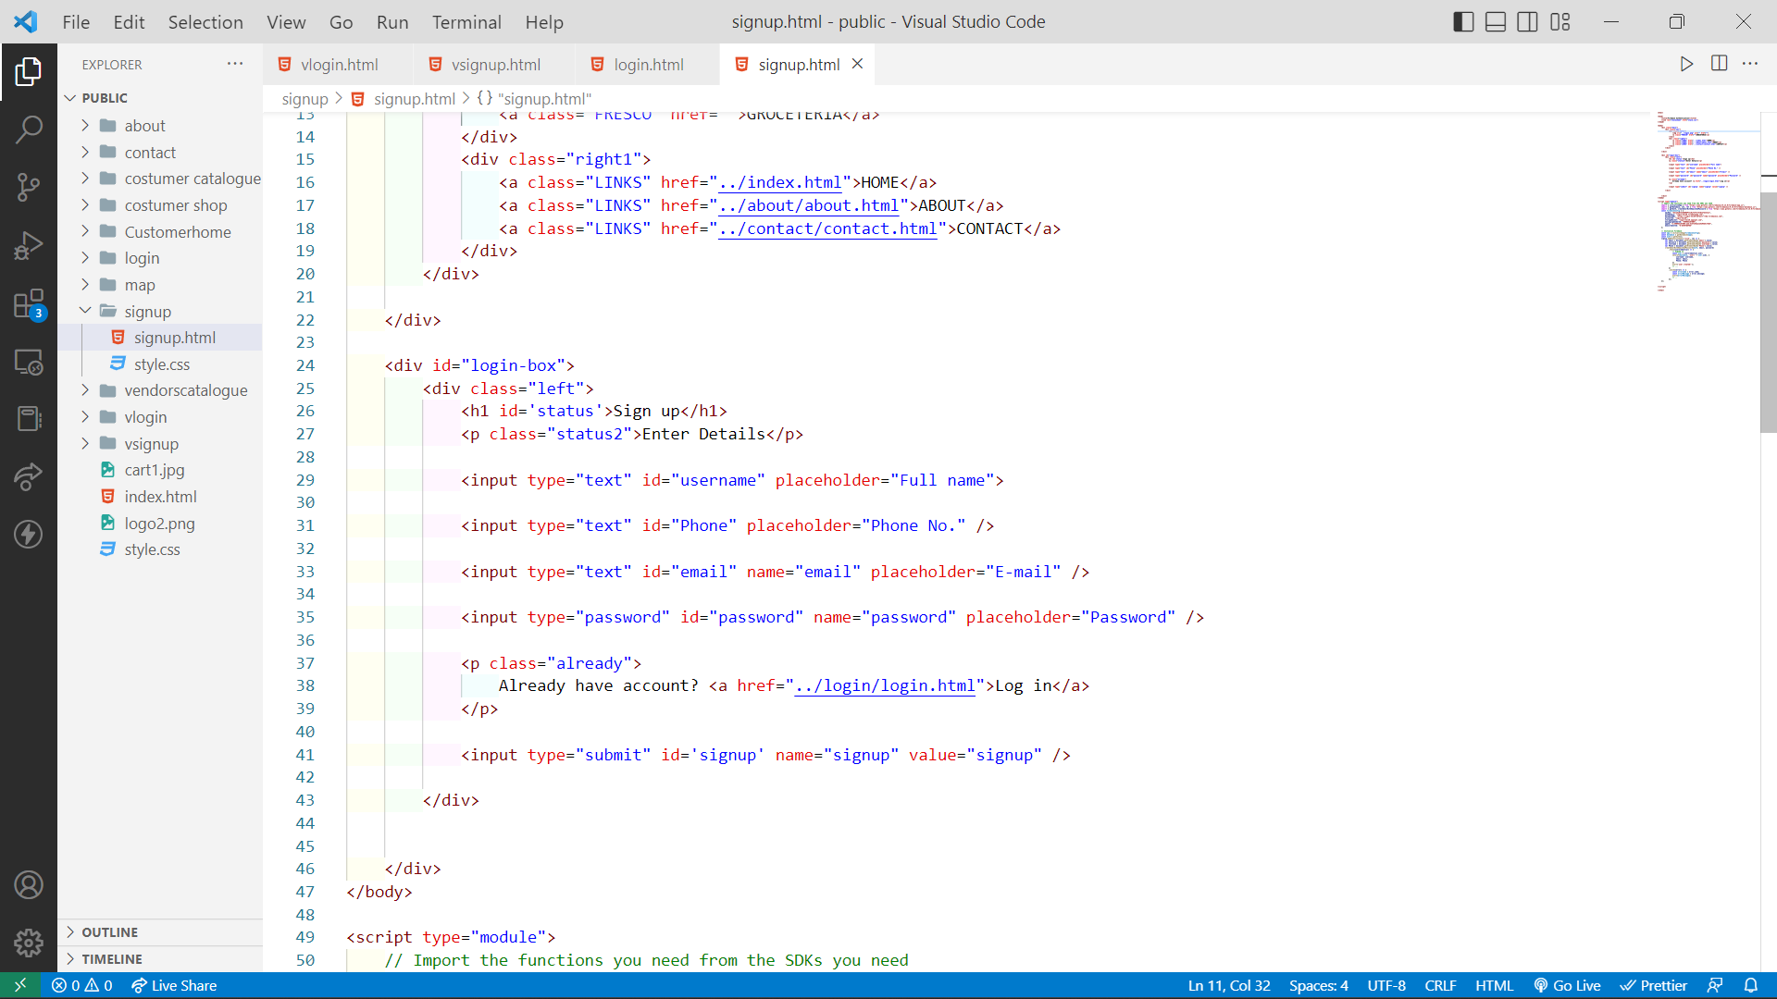

RESULTS / OUTPUT & TESTING

3.1 LANDING PAGE

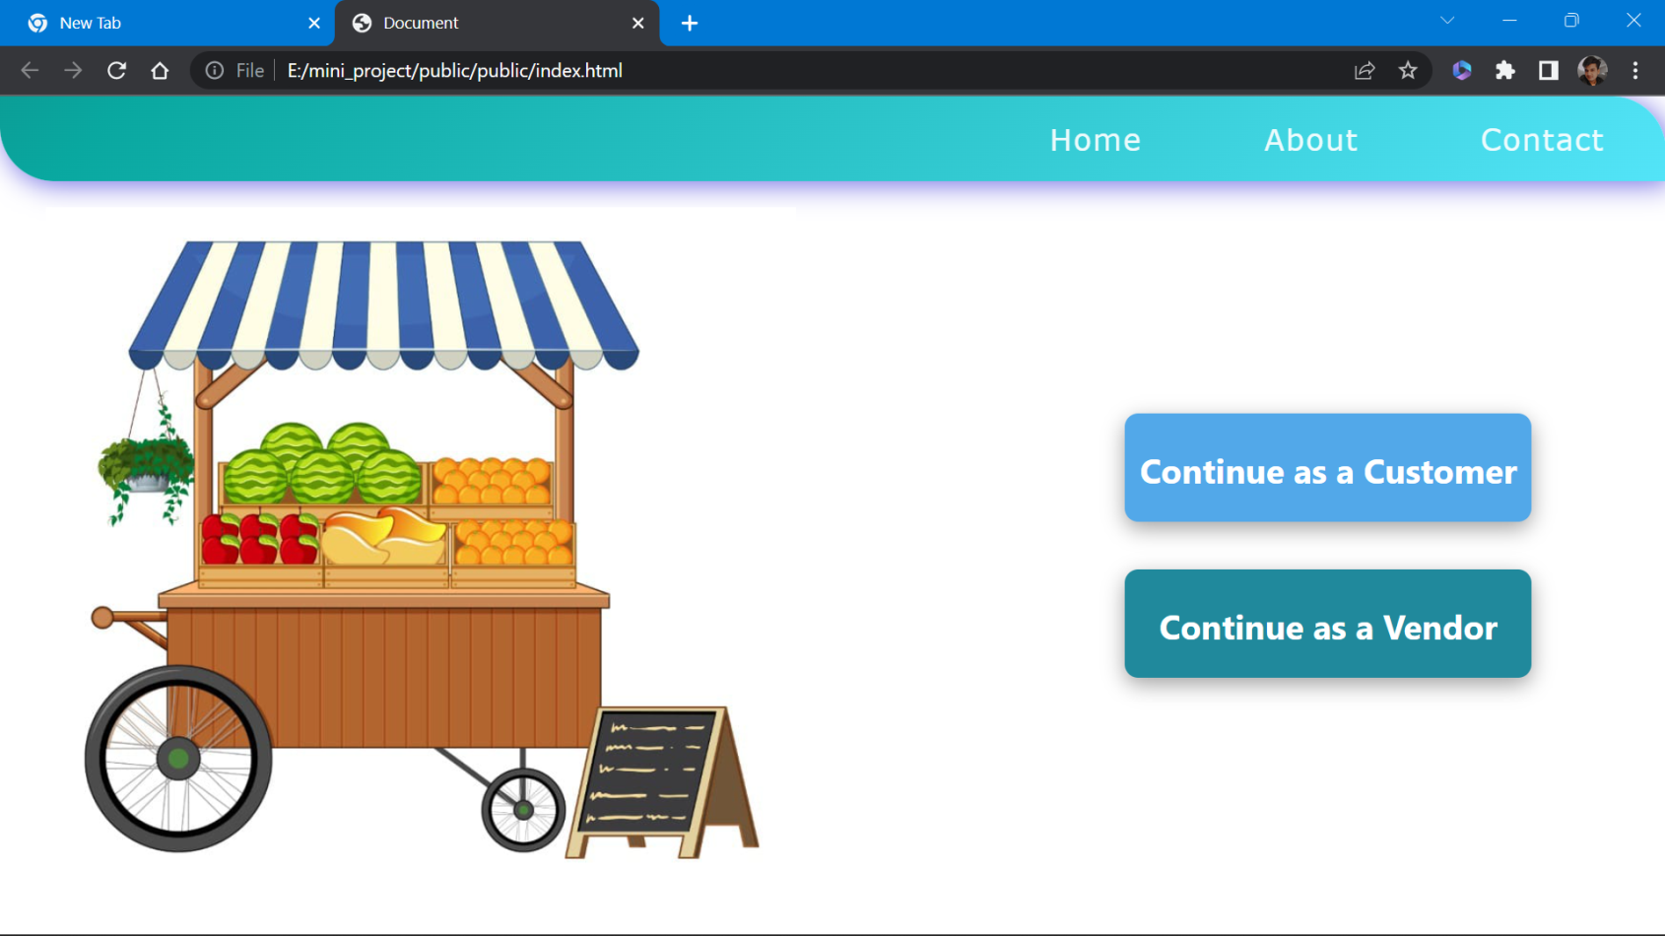

3.2 VENDOR SIGNUP PAGE

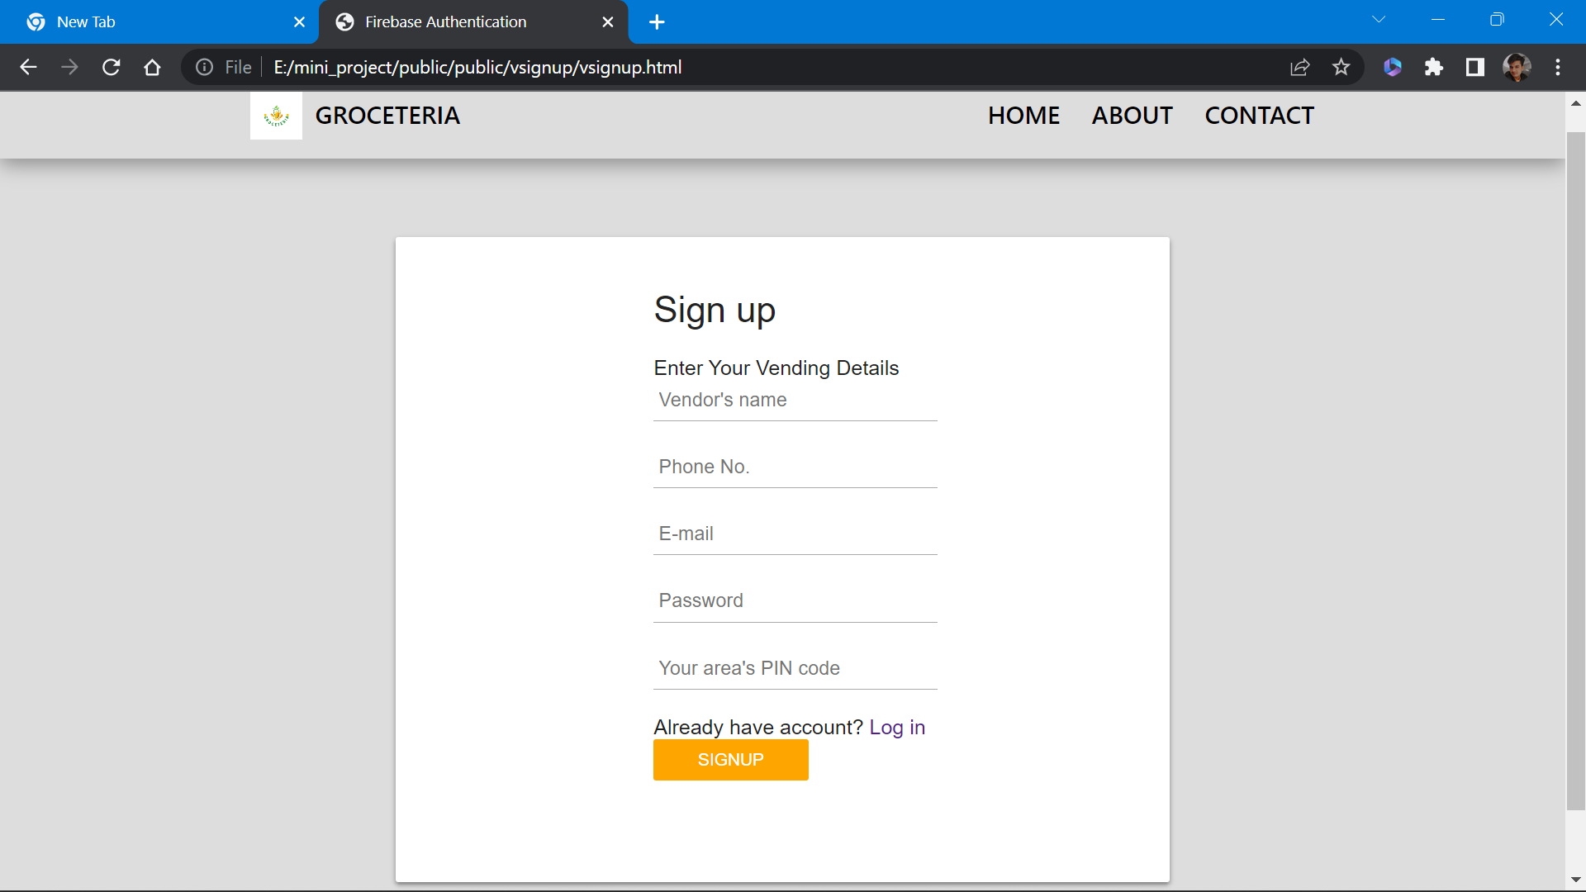

3.3 CUSTMER SIGUP PAGE

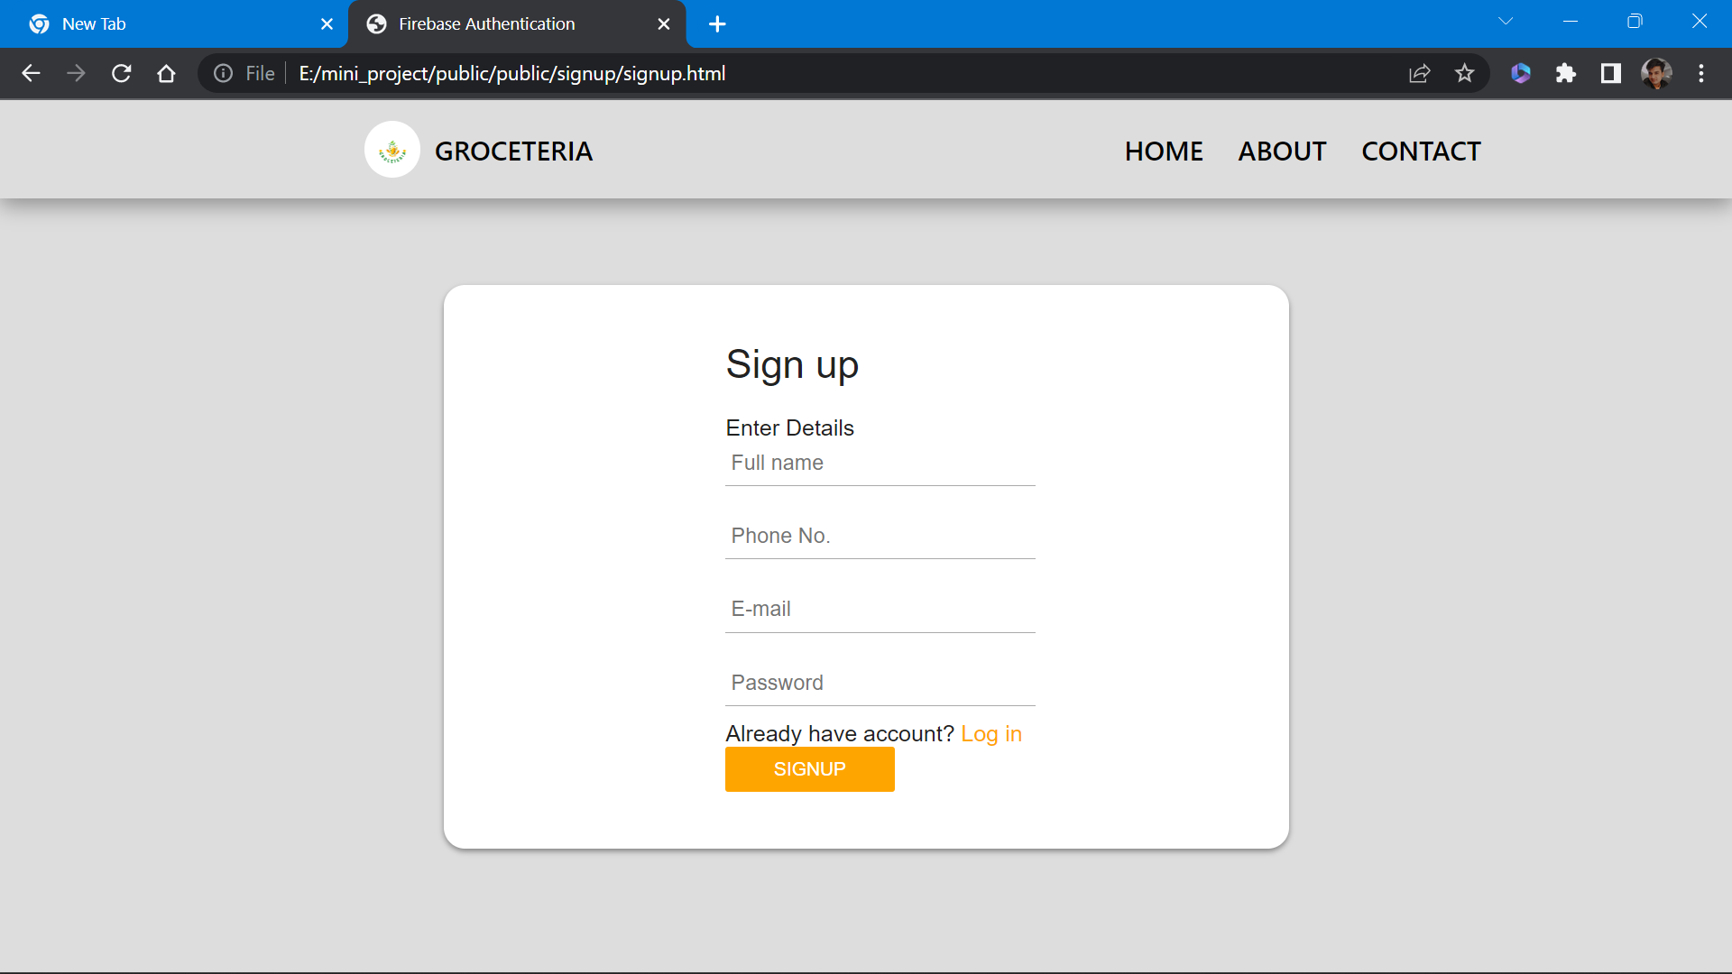

3.4 VENDOR CATALOG

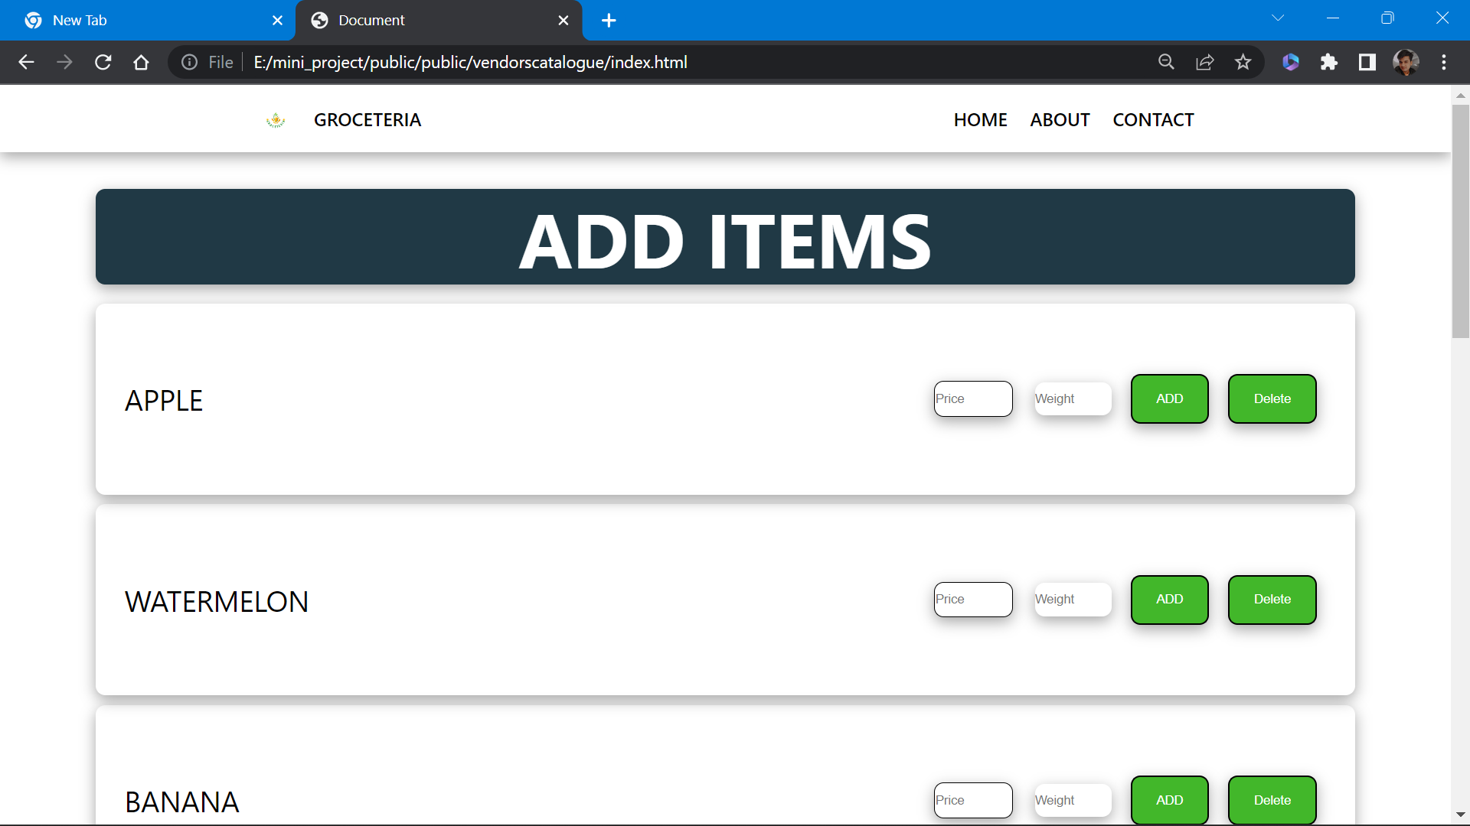3.5 CUSTMER HOME PAGE

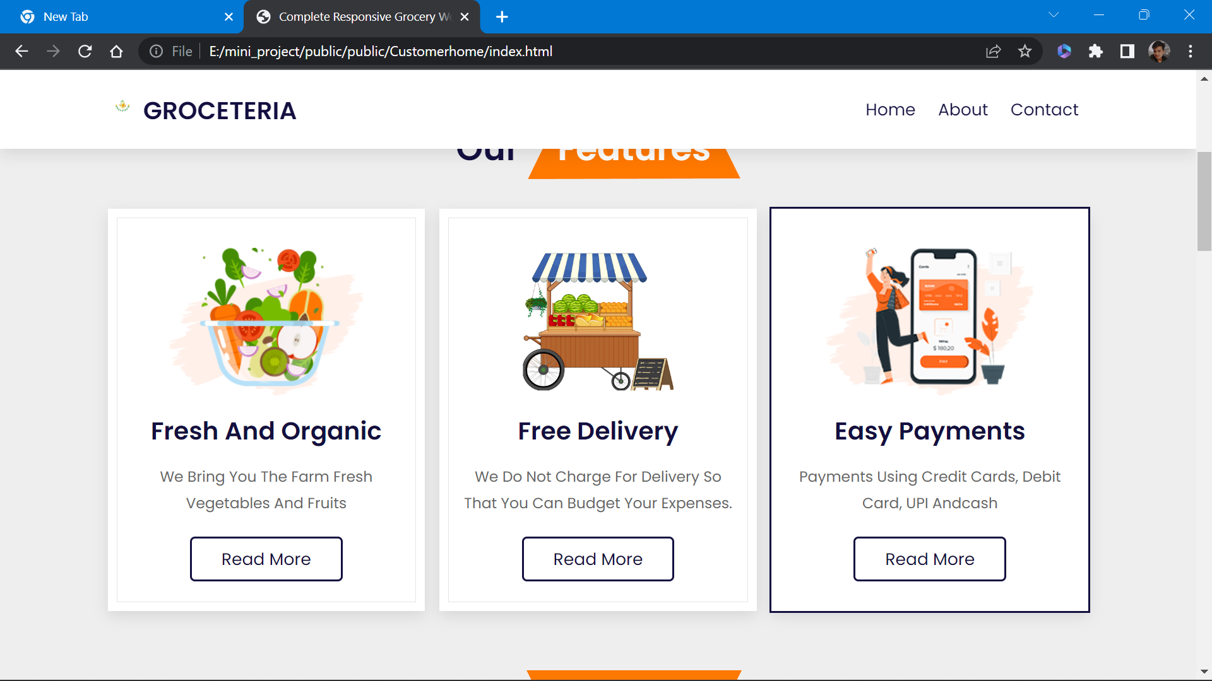

3.6 NEARBY VENDOR

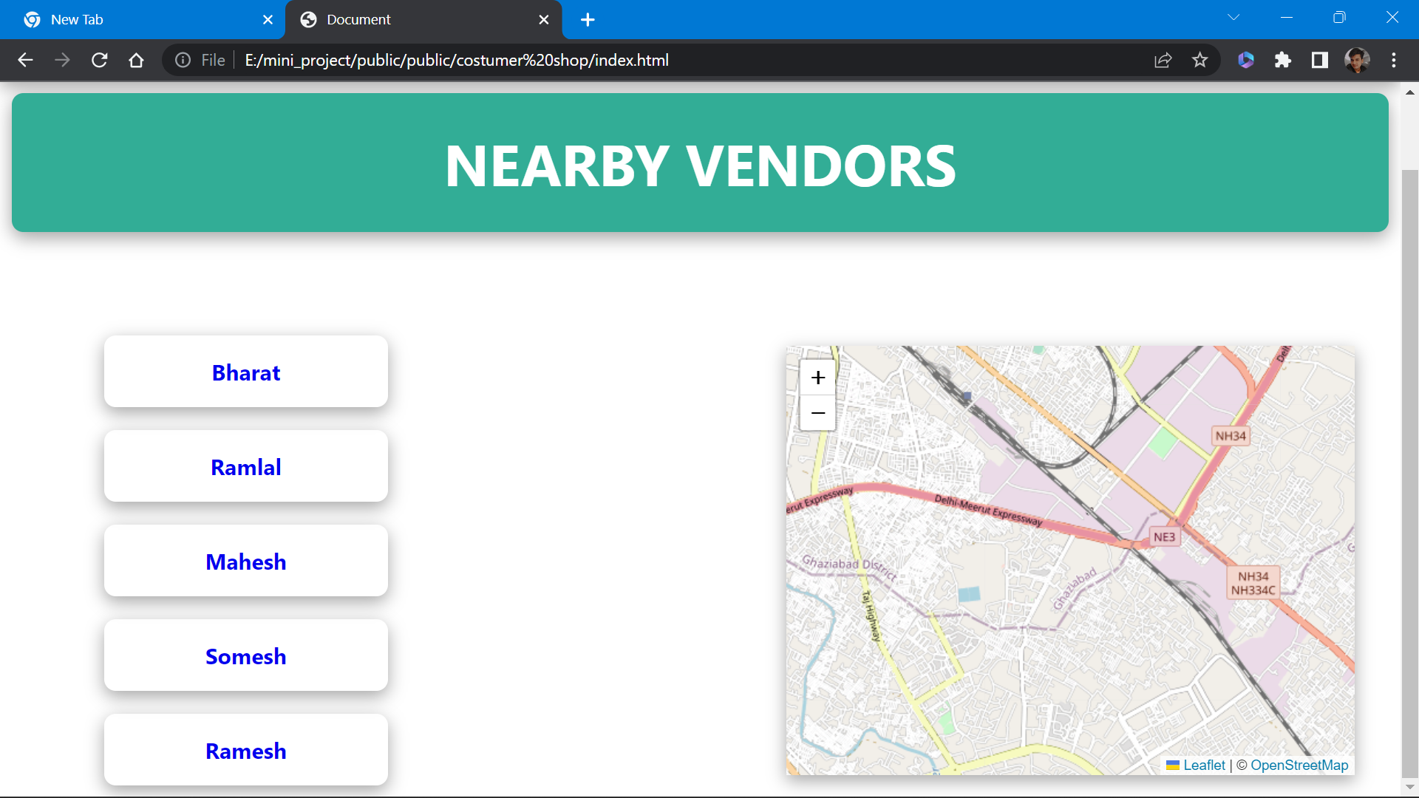

CONCLUSION AND RECOMMENDATIONS